**CHAPTER 1**

**INTRODUCTION**

**1.1INTRODUCTION**

Adder is among the important building blocks of a binary multiplication structure. Recently, systems are targeted at machines powered by batteries, so output power is one of the key design constraints. Circuit velocity, area, performance, cost effectiveness were of primary importance in the past processing power. Energy use was secondary. At the same, electricity use has been granted similar priority in recent times. Perhaps due to the exponential growth in portable computing devices and wireless networking networks that allow high-speed computations and complicated applications of low power, the explanation for such a evolving phenomenon is credited. Besides this high-performance processor consume extreme power which in effect raises the cost of packaging as well as cooling. The power density of VLSI chips consequently increases thereby disrupting the durability. Thanks to many Silicon failure mechanisms such as thermal runaway, junction diffusion, electro migration diffusion, electrical parameter changes kit-based failure including Silicon connectivity failure, it has been observed that each and every 10o increase in operating temperature approximately doubles the failure rate of components made up of Silicon. The lower the current mode control of electrical parts from an environmental point of view, the lower the heat subsided in rooms, which in turn will have a positive impact on the global environment. Lesser energy should therefore be used. Hence a new low-power, high-speed energy-efficient full adder is suggested using Gate Diffusion Input (GDI) method to further optimize the performance of a full adder in terms of energy consumption, buffer size as well as improved voltage Product (PDP). GDI is a innovative modus operandi for wireless low-power circuits. This technique helps to reduce the power usage, the latency of dissemination and the optical circuit transistor count. The approach can be used to reduce transistor numbers relative to traditional CMOS complementary pass-transistor logic (CPL) and dual pass-transistor logic (DPL) architecture. The proposed adder has a transistor count of 14—a reduction of 72.00 percent, 63.16 percent, and 58.82 percent compared to the full adder made up of CMOS logic, sustainable development goals, and CPL, which suggests a reduction in area. To establish the design's independence from technology the proposed adder.

**1.2MOTIVATION**

Addition is the most critical element of the arithmetic logic unit that involves addition almost nearly all other arithmetic operations. Therefore, the primary challenge in the design of any arithmetic logic device is to provide a high-performance adder cell with low power. • There are various topologies and methodologies suggested for effective design of complete adder cells. This work makes use of the idea of GDI technique as signal generator and Full Adder in the design of ALU and its sub blocks.

**1.3 SURVEY LITERATURES**

GDI (gate diffusion input) is proposed by A. Morgenstern, A. Fish, I. A. Wagner-a new low-power digital combinatorial circuit design technique is described. This technique allows to reduce the power consumption, delay as well as area of digital circuits, while maintaining low logic fabrication cost. A detailed methodology for design is described here. Comparison of performance to traditional techniques for CMOS and PTL design is presented. With respect to the diamond lattice, number of devices, postpone and power dissipation the distinct techniques are described. Various logic circuits were designed in various types of architecture. It discusses their properties, reports simulation results

A. P. Chandrakasan and R. Sheng W. Brodersen, is proposed energized by evolving battery-operated applications that require intensive computing in portable climates, techniques which reduce energy consumption throughout CMOS digital circuits whilst also maintaining computation speed are investigated. Low-power processing strategies are shown using the lowest possible supply voltage combined with improvements in design, logic type, device, and technology. It introduces an architectural style dependent scaling strategy which indicates that the optimum voltage is far lower than that defined by other factors of scaling. This equilibrium is accomplished by expanded silicon region exchange to reduce power usage

P.A. Chandrakasan, W.R. Brodersen, are being suggested An approach is being introduced to reduce energy usage for digital systems implemented in CMOS that requires optimization at all design stages. This optimisation involves the technologies used to execute the automated circuits, the design and topology of the circuits, the software used to execute the circuits and the algorithms being applied at the maximum stage. The most important consideration of technology is the modulation index and its regulation which enables the supply voltage to be decreased without any major effect on logic speed. The use of an architecture-based handle higher strategy, which uses parallelism and infrastructure, for tradeoff silicon area and power reduction, can make even further supply reductions. Because energy is expended only when capability is shifted power can be minimized by reducing this ability by selecting number representation through process reduction, optimization of signal similarities, resynchronization to mitigate glitching, logic layout, circuit design, and physical design. The proposed low-power strategies have been extended to chipset architecture for an add dimension terminal that facilitates pen entry, voice I / O and full-motion recording. The entire chipset conducting protocol transfer, synchronization, error correction, packaging, buffering, video decompression and D / A transfer works from a 1.1 V supply and absorbs less than 5 mW

**1.4 ORGANIZATION OF THE THESIS**

Chapter 1 presents an introduction to the organization of motivation, literature survey as well as thesis. Chapter 2, deals with the logic of CMOS. Chapter 3 deals with the input procedure of Gate Diffusion. Chapter 4 explains the program of nature. Chapter 5 discusses the Proposed Program. Chapter 6 outlines the tool used for tanning. Chapter 7 contains information about simulation. Finally , Chapter 8 lays forth the premise and recommendations for more improvement of the possible solutions.

**CHAPTER 2**

**CMOS LOGIC**

The Corresponding Metal-Oxide-Semiconductor (CMOS) is a standardized circuit construction technology. Innovative CMOS is used in processors, microcontrollers, static slams and other digital logical circuits. Furthermore, CMOS technology is used for many simple circuitry and other forms of communications, such as image sensors (CMOS sensor), information converters and uniquely designed handsets. In 1963, Blunt Wanlass awarded CMOS a licence (US patent 3.356.858).

CMOS is often referred to as the analogous metal–oxide–semiconductor (or COS-MOS) combination once in a while.[1] The terms \'complementary-symmetry\' allude to the manner in which the standard CMOS design form utilizes correlative and also blends p-type and n-type metal oxide semiconductor field impact transistors (MOSFETs) for logical functions.

Two main qualities of the CMOS devices are good clamor tolerance and poor static control consumption. If one of the integrated circuits of the pair is constantly down, the combination of arrangements attracts immense power almost instantly during on- and off-state exchanges. Therefore, CMOS systems do not produce too much energy in terms of specific types of reasoning, e.g. transistor – transistor reasoning (TTL) or NMOS reason, which usually maintains them up-to - date although they do not increase. CMOS also permits high logical thicknesses on a surface. Nevertheless, CMOS is arguably the most widely used innovation in VLSI chips to be found.

The word metal – oxide – semiconductor\ 'applies to the functional structure of certain field-impact circuit boards, including a metal input cathode placed on the head of a chloride separator, which is also on the head of a semiconductor. Furthermore, metal is used previously, today the material is polysilicon.

CMOS\ 'applies both to the specific piece of the automatic hardware program as well as to the group of processes used to launch hardware implementation on strongly supports (chips). CMOS hardware disperses fewer resistive obligations than logical families. As this chosen point of view has extended and grown exceedingly important, CMOS systems and derivatives have become daunting.

CMOS circuits use a mixture of p-type and n-type metal – oxide – semiconductor field-impact transistors (MOSFETs) to update logical doors and other sophisticated circuits. While CMOS rationale may be changed for individual display systems, CMOS goods are structured circuits composed of approximately billions of two-type transistors on a circular bit of silicone.

CMOS circuits are constructed in such a manner that all PMOS transistors will either have an impact from the dc voltage or from another PMOS resistor. Similarly, all NMOS semiconductors may either have an impact from the floor or from another resistor. The Transistors component creates low interference between the manufacturer and the network contacts while the input voltage is small and the contrary current high.

The picture on the right shows what happens when a data is attached to both a PMOS transistor (head of the outline) and an NMOS transistor (base of the chart). At the point where the voltage of information An is weak, the direct transistor is in a high obstruction state, reducing the current that can spill through Q to land.

Nonetheless, when the data one output is strong, the PMOS transistor is in an OFF (strong obstruction) state such that it graciously restricts the current performance from the negative to the yield, while the transistor is in an ON (weak opposition) state , making the input from the ground path. Since the blockage among Q the ground is small, the voltage decreases as the current is light.

To put it clearly, the yields of the PMOS and NMOS transistors are correlative to the end result when the yielded are large when the data is low, and when the information is high, the yield is weak. Instead of the information and yield behaviour, the yield of the CMOS loops is the opposite of the details.

Force suppliers for CMOS are referred to as VDD and VSS, or VCC and Ground (GND) depending on the manufacturer. VDD and VSS are remnants from standard MOS circuits which represent network which component supplies.[5] They provide little valid difference to CMOS because the four suppliers are truly source supplies. VCC and Ground are fragments of TTL reasoning however the categorization has been preserved with T.

Progressively mind-boggling frame capabilities, for example, those like AND, OR entries include seeking to regulate the direction between gates and communicate about the logic. At the stage that a route consisting of two transistors in structure, the transistors will have decreased security against effectively measuring voltage, showing an AND.

Appeared on the privelidge is a circuit diagram of a NAND entry in CMOS logic. In the off chance that all the elements in it and B are large, at this stage all the NMOS transistors (base portion of the outline) will lead, only one of those Transistors (top half) can direct and a conductor way will be built between the device and Vss (ground), assisting to carry the yield.

**2.1 PASS TRANSISTOR LOGIC**

There reasons, the architecture incorporated into the Crystal Management circuit represents the usage of the kin. Decreases the door used to give different explanations, is reproduced by removing the exam transistor. Li levels inside the hub resistor are used as a modification in the transmission circuit instead of as a physically binding dynamic voltage switch. This reduces the number of complex devices, but it hurts any step of elevated / low voltages due to reduced gap. Without the need to build a general ratio in the arrangement of each transistor with less awareness of its output if a few devices are saturated, restores the full value of the ordered voltage signal anchored in a reasonable fashion. Another thing is the traditional operation of CMOS transistor shifting with the force of one of the related output rails gracefully in a continuous chain without reducing the voltage level for these purposes. Because there is less distance between the input signal and the output, the creator must be vigilant to explore the household members in an unintended way. Process planning laws limit the activity of the circuit in stealth mode, the exchanging of charges and the exchange medium for suitable activities, which can be prevented. [3] The recreation circuit may need to be properly executed.

A clock sign drives a transfer transistor and unintentionally reaches the transition to either upload or monitor the Vin parasitic capacitance C x, the team charging knowledge signal. In this way, since the clock signal becomes a function with two potentials (CK = 1), the basic theory with mobile dynamics (power C x purpose energization elevated level) and cell processing (after low capacity C x cause) becomes implemented. Nonetheless, in any scenario, the fatigue load NMOS inverter fails to give the required voltage Vx explanation or induces low elevated rates.

And treated through the corresponding crystal \"Differential Transistor Logic \ "implies a family of causes, which is a particular topic. This is not an unintended feature with this home amplifier and lock concept.

CPL justification for the use of a transistor structure may suggest adjusting output has been calculated to chose between a CMOS transfer gate driving inverter comprising a yield equivalent to the corresponding nMOS and pMOS transistors.

Apart from simultaneous transmission control for crystal utilizing two N and P-channel diodes, the inverter stage needs a dual power management process with a portion of crystal contributing to each power. But it has a fast low content of knowledge, as it is limited to the capability to push the heap. Dynamic and static seed crystals control is available, comparing output in terms of running speed, strength and low voltage. [6] Implementation of bonded flexible circuit voltage decrease, diamond barrier more visible control; initial circuit surface voltage is high relative to regular voltage, greatly limiting the number of successive phases. The desire to monitor the transistor, the need for more evidence, is always attributed to the opposite of the knowledge flow.

Interaction also includes high regard, e.g. designed interface circuit to generate two resistance reasons or explanations of any kind, will be used as a private residential fair dc voltage speaking, 1:00, functionality could be specific needs only achieve the inside of the target unit. In most cases, the TTL yield does not rise high enough to accurately detect Ground 1 via CMOS input, which does not close the related source of potential, especially in the critical current, only high input impedance CMOS input This problem is to create a gadget 74HCT culture, but to recognize the use of innovative CMOS TTL input control levels. These systems operate best on a 5V power supply. Given the fact that the HCT is slower than the original TTL (HC 's unique explanations for identical TTL speed) they are building a replacement TTL.

The greater or lesser voltage point of the presenter, or the use of self-assertion, and also the physical state, shifts the rates within a circle. Large speed and low dynamic status can be conveniently mixed: for example, a coordinate reading circuit may have a think about it this way of low chip only by choosing ram, but address details and high bit are conventional dynamics. - one so often unlocks a basic design principle described by the level of reverse dynamics (see De Morgan \ 'hypothesis). A good-performance flag is a double-speaking condition correlated with the numbers 1 or proof of the conditions, the voltage from the two higher ones: high voltage stress or \ 'label \' 1 counterpart, and lower tension to the related speech 0 or \ 'space \.' Low-state situations act as a double-speaking signal number 1 or sound to be checked by a lower portion of the two voltages: men.

## Two different voltages typically apply to best network state manuals, but are only used for other family purposes. Cap is the definition of a unit. The wire is \ "small \" when the \ "solid \" above is below this point. Unclear intervention and the resulting volume of road traffic in the arabian peninsula is very easy to carry out. The issue with the circuit of creators is the change from the stage of output, the goal of all the effects is not confounding constraints that hold them at a distance.

## This is not unexpected, providing more versatility in the usage of the voltage level; for example, 0 to 2 volts will talk and 3-5 01 will manage the cause for voltage. 2 volts to 3 volts can be unreliable, and where triggers have arisen only in horizontal or problematic position when advancing, the electronics can 'T iN show specific voltage ranges. In any scenario, barely any reason for such a circuit can be considered disadvantages and will definitely be rolled out decrypted symbols, knowledge similar to 0 or 1 may be point data, and possible abnormal con.

## Nearly all computerized symbols for each internal circuit use the same consistent levels-in any event, the level volatility typically starts at the next picture. Top management People use specialized circuits for another purpose: horizontal level shifter circuit computerized system Regular level shifter 2 has been used, one for each loop.

**2.2 TRANMISSION GATE LOGIC**

As a transistor, it is similar to a relay, or the pi controller frames could be turned from all DC voltage in both angles. Pending theory, two field effect transistors of the transmission gates, in which the inside of surface terminals (bulk) is attached to the input terminals upward from the-compared to the conventional separable field-effect transistors. However, only the source / drain connections of the transmit antennas, two transistors, n-channel MOSFET and p-channel MOSFET are wired together. Their terminals are connected to each other by means of a NOT gate (inverter) to create a control terminal.

The substratum terminal attached to the comparison contact is equipped for separable transistors, and there is no parallel diode (body diode) where the resistor is routed to the resistor. As the flow transfer gate must be blocked in any direction, though, as well as the substrate terminal attached to the corresponding supply voltage potential, the substrate must be in the opposite direction to insure that the electrode activity has still been in place. As well as the substratum side n-channel MOSFET, the favorable supply voltage potential and the substratum terminal connected to the p-channel MOSFET are linked to the negative supply voltage potentials.

The gate of the n-channel MOSFET often has a negative output voltage value, whereas the input signal is a rational zero (negative power supply value). The p-channel MOSFET gate terminal is activated by an inverter, which is a favorable voltage supply potential. The n-channel MOSFET is used, irrespective of the switching stations (A or B) – the source voltage is usually negative and the p-channel MOSFET is positive. As a consequence, all transistors are turned off transmitting screens.

Whenever the input signal is logic 1, the N-channel MOSFET port terminal has a strong output voltage capacity. The p-channel gate terminal MOSFET is in the negative supply voltage range by the inverter. Since the transistor substratum terminal is not connected to the output terminal, the drain terminal and the output terminal are roughly the same, the voltage disparity between the capacitor gate terminal and the beginning of these activities.

The transmission gate shift terminal is raised to a neutral input voltage, an positive gate-source voltage (gate-drain voltage) appears in the region of the MOSFET N-channel, and the transistor starts to work and the transmission door is turned open. The voltage on the interface gate switch terminal is now gradually raised to the positive input dc voltage, such that the gate-source impedance (gate-drain voltage) n-channel MOSFET is turned on and starts to shut off. Simultaneously, the P-channel MOSFET has an aggregation of negative gate-source voltage (wire-drain voltage) such that the transistor begins to work and the transfer gate switches.

A receiving gate across the whole DC voltage. Based on the voltage transfer resistance, which affects the transmission path, to be converted, which refers to the amplitude of the presented control curves transistors.

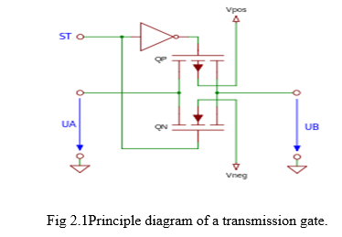

The input signal ST should be capable of controlling various logic levels depending mostly on supply voltage as well as the voltage switching.

**2.3 power consumption**

One benefit of the CMOS is that the NMOS high to low as well as the high to low output transformation is fast both so because pull-up transistor has a low resistance when switched on, unlike the NMOS load resistor. The total cost signal also switches between higher and lower voltage pipes. This strong, almost symmetrical response also helps the CMOS to be more immune to noise.

Power ratio, and also though the NMOS logic circuit is flipped ("dynamic control"), the MOS logic dissipates fewer power dissipation from CM OS. In traditional nano-devices 90, the ASIC norm will take a reversed performance of 120 ps, which happens once every 10 nanoseconds. When some of the transistors are turned on, the NMOS logic distributed the power current path through Vdd to Vss through the resistive load and the n-type network.

Since they flow down near zero static CMOS gates is very productive under idle circumstances. Previously, the usage of resources when designing a CMOS system is not a big concern. The design parameters, such as speed and location, are influenced by these factors. Because as submicron stage of the semiconductor industry is increased significantly far below energy usage per unit region of device.

Substantially affected, energy production output throughout the CMOS circuit attributed to the aforementioned two components:

Effective discharging

When the threshold conductors semiconductor will be off

NMOS and PMOS semiconductor providing a gate-source voltage level becomes smaller than present (called the newest sub-threshold) around the device gradually decreases. Traditionally, CMOS design elements at a higher voltage level far exceed its input voltage operation (VDD Vth may be 5 V and 700 millivolts may be NMOS and PMOS). Natural transistor is a special form with a near-zero applied voltage of the CMOS transistors.

Tunning current thru the tunnel oxide gap

SiO 2 is an insulator so extremely fast electrons reach the very thin coating layer at very small concentrations; the likelihood of an oxide layer reduces exponential. A transistor with a depth of less than 130 nanometres, the tunneling current must have 20 goals in the most efficient or thinner gate oxide.

Diode leakage in reverse current

Although the dispersing region and the holes (e.g., n-well and p-type diffusion), the and well substrate (e.g., n-well and p-substrate) are created by the reverse bias and the present leakage of various individuals. As a consequence, the conventional method measurement of the leakage diode is very low relative to the sub-threshold as well as the tunneling current may be ignored.

The current rate of success of the circuit conflict

This need has to be further extended. (In March 2014)

Active discharging

Loading power

The thermal power generated by a specific CMOS circuit charges the load capacitance (mainly the gate capacitance and the wiring, and the drain-source capacitance and other capacitance) as well as the offset. Through the full loop of CMOS logic, the water is moved from the VDD to the load space, and then from the loading period load capacity (CL) via the whole discharge grinding phase. As a consequence, the total Q = CLVDD VDD from the complete load / discharge cycle falls to the table. The voltage level of the current load capacitance shall be determined by the switching frequency of the diet, and shall be re-calculated by the standard strength switch.



Because most doors at each clock cycle do not operate / switch, a component, named the operation component, also accompanies them. Now, automatic depletion of power can be updated as.  P = \alpha C V^2 f .

A clock in such a structure has a developers and consumers of α=1, because every process rises or falls. Many data have a developers and consumers of 0.1.[6] When the right critical understanding on a node is determined along with its activity factor, the adaptive output power at a certain node could be efficiently measured.

Many current clock control network architectures rely on the dissipation of power associated with the clock signal. Increasing die sizes and operating frequencies also resulted in a proportion of a chip power dedicated to clock delivery becoming large, and often disproportionate. The complex Power Equation will clearly describe this causality:

P = CV2f

Where C is really the touch sensitive load, f is the intensity of the switches and V was its frequency voltage swing.

A third way of reducing clock switching losses is to shut down the control signals to unused chip portions. This technique was used for the DEC Strong ARM microprocessor to make significant benefit. Conditional clocking is estimated to have reduced the output power of the goad clock network nearly fourfold.

In logic architecture, reasoning or 1-0 when going from 0 to 1, marginally increase the flexible stop if there are no unique characteristics, large gate still logical cluster (enable performance and ED). An example of this is the sub-pipe structure of ALU and a number of specialized microcontrollers. If an ADD event is complete, logical routing should not be used for logic (AND, OR, etc.), multiplication, shifting, and the like. When the inclusion of the hypotube interacts with the other input of the hypotube, the complex energy usage may be minimized because the ADD has strobe input data through such cross-pipes.

Dynamic power usage is mostly two fields (how many transistors need to be maintained) and a function of the circuit. For eg, you can need to build a pull device of two non-parallel drives to the P-FET gate (both inputs and logic 0 and the diode switch opens to VDD). This parallel configuration increases the static part of the power supply circuit, since the active defense of the transmit antennas is the opposition 1/(1 / R1 + 1 / R2) of the transistor.

The Static CMOS gate can be consumed in old hardware. Energy is a significant limitation in the construction of emerging technology. According to the scale of the capacitor, the circuit scale of the capacitor as well as the clock speed, the performance power is plummeting.

***Instantaneous Power***

The instant P(t) power drawn from of the power source is roughly equal to the iDD(t) supply current as well as the VDD voltage supply.

***P***(***t***) **= *iDD***(***t***)***VDD***

***Energy***

The electricity produced through given period T is P(t) integral



***Average Power***

The mean power over all this time interval is



***CMOS Power Dissipation***

In CMOS loops, power dissipation arises from three elements

Variable dissipation by reason of

· convective heat of sub-threshold by OFF integrated circuits

· Current digging a tunnel thru the gate oxide

· Reverse-based diodes leakage

· Current implication in ratio modules

Dynamic dissipation by way of

• Capacity charging / discharging

· Existing stop functioning when PMOS and NMOS systems are partly Enabled

**P total = P static + P dynamic**

We had also discussed almost all of the factors for variable evaporation before. Under 130nm of static power eventually becomes a primary design issue, static power dissipation can be compared with dynamic power Rationed circuits (e.g. pseudo NMOS, discussed later) have more static dissipation

Dynamic Power Dissipation

Main cause of dynamic evaporation is load capacitance setting. Suppose that load C is decided to switch at exact look fsw between VDD and GND. Load is prosecuted and Tfsw times released over time T. A cumulative charge of Q = CVDD is passed between VDD and GND in one full charge / discharge process

The mean dynamic diffusion of the force is



Taking the integral of the current over interval T as the total charge delivered during time T



Because not all doors turn per loop of the cycle the amount above is multiplied by α. α=1 for clock, α=0.5 for full details, α=0.1 for scientifically static CMOS, and α=0.1 for non-zero output and fall periods (slew), all NMOS and PMOS are ON Induces low voltage current based on input mauls and output ability.

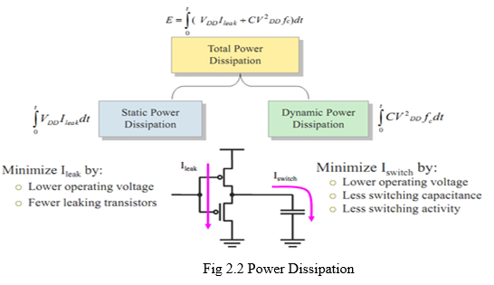

**CHAPTER 3**

**GATE DIFFUSION INPUT (GDI)**

This strategy relies on the usage of the GDI base unit as seen in Figure 1. The base device provides a first glance at the regular CMOS inverter, but there is a clear contrast: GDI cell involves four sources-G (NMOS-substantial contribution of the inlet channel and PMOS-transistors), P (external contribution of the pMOS-transistor transmission hub) as well as N (external contribution of the nMOS-transistor dispersion hub). The center (dispersion of traditional two transistors) However, details can be included in the development of power circuit or port specification. Table 1 demonstrates the details given in the specific GDI discrepancy cell how a simple Boolean requires various capacities. Most of these capabilities need an enormous (6-12 transistors) CMOS gate (as in the application of PTL standards) but are incredibly simple GDI design processes (only two of each transistor size). GDI has become more complicated and fewer inlet pathways, smaller transistor papers, and higher power delivery. Any of the details may be specific door GDI cell by inserting fact. Since the buffers is feasible VT pressing down is defined in depth in[8], the system is seen as CMOS (and SOI) similarity.

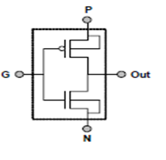

Fig 3.1 GDI Cell

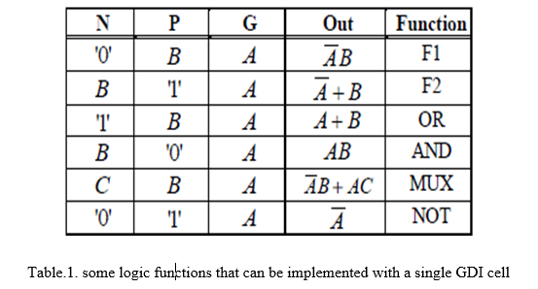

**GDI Implementation of the C-Element and SR-Latch**

The GDI circuit configuration has proved to be compact and high output power compared to the CMOS and PTL outputs. In the analysis, he accompanied us, and he looked at GDI Celement & SR-Lock. For purposes of complex, conventional and symmetrical peripheral output circuit (FIG . 2), which has finally differentiated the most energy-efficient and rapid usage of[9] C-4 Interaction part circuits. Additionally, we 're still talking about the static (fixed) chain.

The complex GDI C circuit part is shown in Figure 3a. This requires the necessary distribution of GDI cells around the region. Remember that the usual dispersion of the GDI cells is both input (B) and yield (C). Likewise, the outer center of each GDI cell dispersion is used as a bi-directional terminal. Active GDI C-assembly use just four transistors, like comparison and six CMOS active circuit transistors (FIG.2a). GDI C-The low input component appears in FIG. 3b. 3b. It needs eight transistors instead of the CMOS circuit (FIG. 2D), the inverter output is not needed at 10. Contributions of a two-way GDI-consistent generation circuit through the nMOS transistor and the pMOS. Interestingly, the CMOS C-assembly consists of two pull-up Transistors interconnecting in the apparatus. This distinction increases the GDI C-delayed contextual portion. The chosen position for versatile low power is especially unusual, usually used to minimize power usageAlthough the input of the GDI two-circuit transistor gates, the B output does not drive any GDI inlet channel cells; instead, it is only the output of the gate through the transistor.

NOTATION for the development of dual power, the other knowledge (AN) and the performance of (C). Such dual monitoring is structured to popular the risk of unsafe development. This beneficial role in the alternative program, standard nuclear amnesty, non-hazardous square framework, is very helpful. In either case, when emitted by two transmitting transistors, B signals are devalued with one VT in any situation. Similarly, there is a need for indicators to push the mound, albeit in comparison to the critique of the amplifier. Therefore, the C-1 portion of the B C process has been significantly obtained. Ultimately, raise the burden (of which source B) by sending the signal B past the stage. This problem can be dealt with in the cradle.

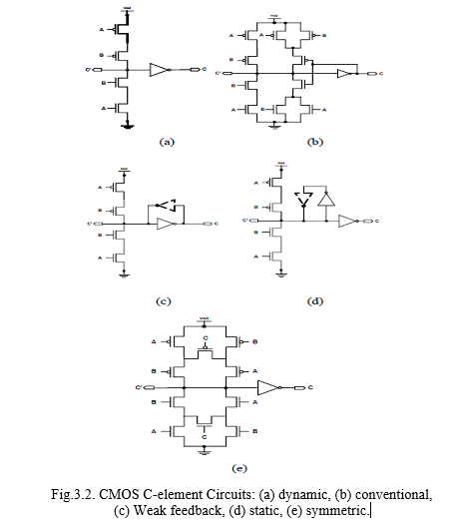

GDI C cushioning device shown in FIG 3c. For this scenario, instead of through the one pair to the current inverter pool, the inverter data is transmitted pre and post C circuit. This can render the charging of the external and internal gates in the circuit more effective. In response to their function of expanded, swing inverter recovery, no decrease in VT performance has been observed. Nevertheless, the small window output is the GDI C buffer feature.

GDI and the three-input CMOS C-Element 4 are shown in FIG. As mentioned above, the issue of high pMOS CMOS C-element in the stack has been minimized by the GDI circuit.

In addition, the input dimension is mutually exclusive to C-that it can be effectively interpreted by the SR lock, where SR lock is seen in the FIG. FIG GDI has accomplished 5 seen. 6. The input is inverted, often beneficial for asynchronous applications (FIG . 5). Application is effective: the SR latch GDI requires only two cells (four transistors). Both architectures are F1-and F2-based (defined in the F1 and F2 functions in Table 1).

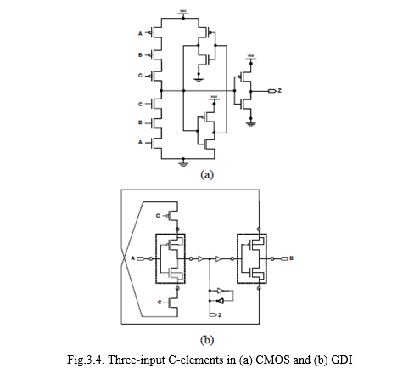

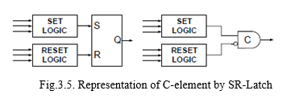

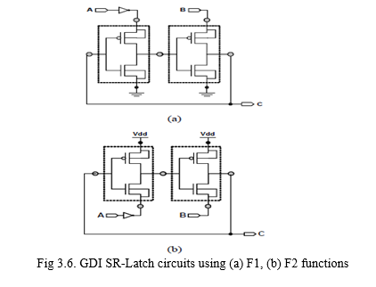

**CHAPTER 4**

**Existing Method**

The GDI methodology enables a broad variety of logic functions to be realized utilizing basic two transistor-based circuitry setups. This scheme is suitable for the construction of swift yet low-power circuits, and decreases the amount of MOS transistors relative to CMOS and other current low-power strategies, whereas the logic standard of swing as well as static dispersion increases. This also makes fast top-down approach via a limited cell library[5]. The simple GDI cell is shown in Fig. 4.1.

1. The GDI cell is made of one nMOS but one pMOS. It appears like a CMOS inverter. Since the origins and related substrate bases of a transistors really aren't related to the supply throughout the case of GDI, they may be arbitrarily biased.
2. This has three reference terminals: G (nMOS and pMOS shortened entry gate), P (pMOS reference source) and N (nMOS entry source). The power is obtained from D (nMOS and pMOS shortened drain terminal)[11].

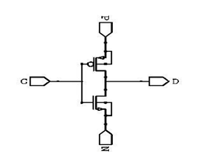

GDI basic cell consisting of pMOS and nMOS

GDI logic type solution uses less silicone region relative to other logic types because it consists with less switching frequency. In view of the fact that perhaps the region is smaller, the size of the node capacitors would be lower, and for this purpose the GDI gates provide smoother activity, which demonstrates that the GDI logic form is a extremely effective design process.

We can realize various bowles with a simple GDI unit. Table I illustrates how various Boolean structures can be understood by utilizing specific GDI cell reference arrangements.

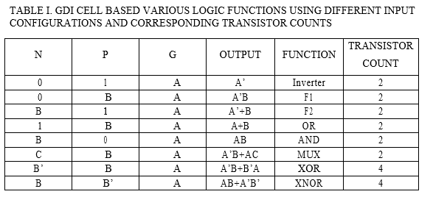

* 1. **ARCHITECTURE OF PROPOSED GDI FULL ADDER**

The suggested framework designs a complete adder circuit utilizing Gate Diffusion Input (GDI) technology. Use this method, a low power wireless circuit can be built in an embedded device. The transistors used for the circuit is small, so the circuit is used to reduce both the latency and the power usage.

Total adder is a hybrid circuit that conducts 3-bit arithmetic operation. Addendum found an integral activity in arithmetic logic machine and optical signal processing. The 1-bit complete adder comprises three input bits and two output bits, the first two input bits are A and B called data manipulation language ( dml, as well as the third serial data Cin is a bit brought in through the prior less important point, the output bits named amount are the product of the additional operation that carry out data for the next addition process, and the statement is named total.





The proposed architecture consists of 16 transistors, namely two XOR gate cell for the production of sum or one multiplexer cell for the production of carrying out, as seen in Figure ( 1), the block diagram shown in Figure ( 2), and the truth table of the planned complete adder presented in Table I.

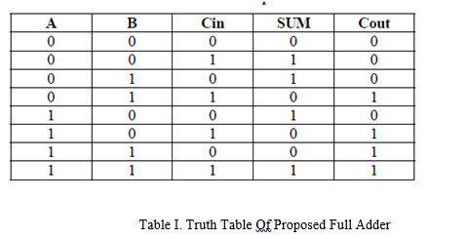

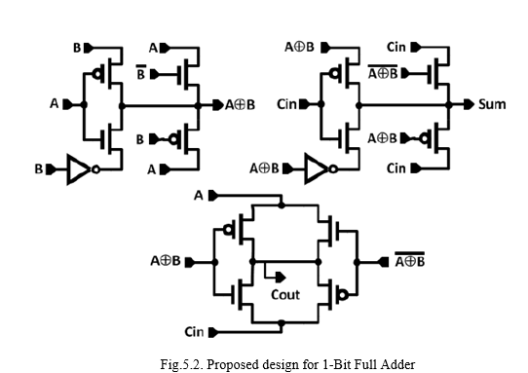

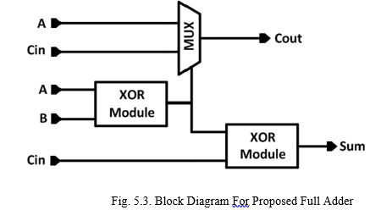

The biggest drawback of utilizing the GDI method is that a wide range of features may be introduced with this methodology. Table 2 demonstrates that GDI can be used for the implementation of different designs such as MUX, AND, OR, etc. The most complicated application among these is the construction of the MUX, which can be achieved with 2 transistors. Though it takes 8-10 transistors for the design of MUX utilizing certain traditional techniques. The key downside of the GDI methodology is the loss of swing. It is attributable to threshold failure and to remove it, we need to use silicone on the insulating material or twin-well operation, which is very costly. Developing a full adder The main town is the XOR gate utilizing GDI technology.

**CHAPTER 5**

**Proposed Method**

Creation of a modern energy-efficient complete hybrid adder introduced utilizing the MVT-GDI solution. According to ULV proposed circuit, the semiconductors is in the semi-threshold / weak-inversion area, and the sub-threshold currently of the MOS system is given by (1).

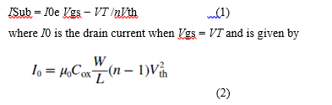

The VT variable is the modulation index, Vgs is the source voltage gate, n was its transistor's subthreshold slope factor (n = 1 + Cd / Cox) and Vth is the transistor's temperature coefficient (kT / q). From (1) it can be realized that the output of the sub-threshold CMOS digital logic would be substantially deteriorated because of the overall rise in the delay. Since the sub-threshold & gate leakage dimensions for GDI cell have been shown to be considerably lower than a static CMOS lock, there would be a substantial effect on GDI circuit output due to the weak logic swing induced by the VT decline. In the proposed design, the transistors that have threshold fall in the main path are substituted with low VT integrated circuits to will this effect. Using high VT phones in non-critical trails, however, can reduce power consumption, but at ULVs, this can lead to a design failure in functionality. Therefore, the authors choose not to use high VT cells in the legislation in the united to improve the Efficiency which is very important in the activity of sub-thresholds to mitigate energy usage. The size of transistors often plays a key role in determining system efficiency. Initially, the sizing of the transistors is done on the basis of the theoretical basis of the complete adder circuit design and the CMOS of the values initially signed to achieve the superior results in terms of A modeling of energy usage. Table 1 summarizes the configured disk image of the current complete adder architecture.

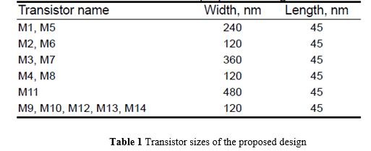

The feature of the proposed adder architecture and its construction is clarified as followed.

**5.1 Proposed hybrid full adder design**

In general, a simple 1-bit complete adder will reflect the logic like in (3) & (4)

 3

 4

The full adder developers to develop only employs 14 semiconductors as seen in Fig. 1. This comprises primarily of five logic structures developed using MVT-GDI methodology. One XOR / XNOR, two multiplexer's, one Swing Restored Transmission Gate (SRTG) the other is Swing returned Pass switching regulator (SRPT) block. The XOR / XNOR block is produced using GDI technique. Because there is no voltage decrease in the direction of the inverters used in XOR / XNOR tubes, we are integrated into regular VT products. Because the GDI MUX-1, transfers the XOR (A AXOR B) and XNOR (A XNOR B) outputs with such a control input (Cin) to get the total element. Thus the (3) can also be interpreted as in (5).

 5

The carry output (Cout) is produced by the MUX-2 GDI, which transfers data the Cin & B inputs from of the XNOR logic (A XNOR B) output of control panel. Then the (4) may also be Performed as seen in (6).

 6

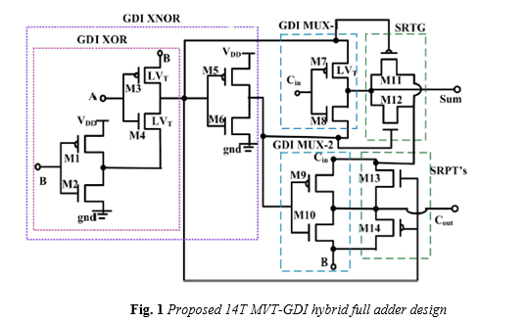

Nevertheless, the current configuration appears identical to other previous XOR / XNOR logic-based models and recent GDI-based designs by developers, but with just 14 transistors, neither of the former designs offers complete logic swing. Within the conceptual architecture, maximum swing is maintained using an SRTG at the total output but SRPT's at the performance executed (Cout). It can be observed that the swing restore transistors (M11, M12, M13, M14) are 'Up' when a VT decrease occurs at the performance of the GDI MUX1 and GDI MUX-2 generation of sums to provide complete swing logic. Because in most cases there really is no VT decrease at the performance as shown in Table 4, the transistors (M11, M12, M13, M14) are also integrated with normal VT transistors.

**CHAPTER 6**

**TANNER EDA TOOL**

The tool used for simulation purpose for the research work is tanner tool version 8.3. The features and functionality of this tool has been described below:

**6.1 Simulation Tool**

The design process for electrical circuit production requires an essential step of pre-fabrication testing. Due to the costs and time constraints involved with the manufacturing phase, reliable testing is essential for successful design. The purpose of the EDA tool is to start designing and verify the function of a circuit by numerically resolving the quadratic calculus which characterize the circuit. Such results of simulation allow design teams to verify and great-tune designs before posting them for manufacture.

Tanner EDA method is a complete system for the modeling and development of circuits including:

**Schematic Editor(S-Edit)**

Schematic editor is a versatile kit of concept capture and visualization that can create T-Spice simulations that can be used directly on the netlist.

**· Circuit emulator T-Spice**

T-Spice simulates analog & mixed analog / digital circuits easily and reliably. The simulator uses tables or C functions that provide the new and strongest system modals. T-Spice provides an expanded SPICE input language variant which is compliant with all industry standard SPICE modeling programmes. Both SPICE 's system types are provided, as are resistors, condensers, inductors, reciprocal inductors, single and combined transmission lines, current sources, voltage sources, regulated sources and a full complement of the new advanced Berkeley and pholops Labs semiconductor product models.

**Waveform Editor(W-Edit)**

W-Edit shows output waveforms of T-Spice simulation, as they are produced during simulation. Visualizing the complicated numerical data arising from VLSI circuit simulation is important for evaluating understanding and optimizing such circuits. W-Edit is a waveform display that offers ease of usage, control, and pace in a versatile setting optimized for graphical analyzing data.

**·Layout Editor(L-Edit)**

Tanner EDA platform provides L-Edit for template editing, dynamic DRC for real-time interface rule testing, DRC template for hierarchical DRC, Schematic, Node highlights to show all node-related geometry, and SPR for basic position & path cells..

**T-Spice**

In order to transform thier ideas into architecture, you need to be able to model large circuits time and with greater precision. That means you need to have a simulation device that provides short run times, combines with other modeling resources and is compliant with industry requirements. With a simple-to-use user interface and a quicker, more natural programming style, Tanner T-Spice circuit simulation puts you in charge of simulation work. T-Spice allows more precise simulations by promoting the new transistor models like BSIM4 and thepennstate Ph fillips (PSP) model, with main features like multi-thread help, system state visualization, real-time sound wave viewing & analysis and even a command wizard for easy SPICE syntax development. Because T-Spice is compatible with a wide range of design solutions and starts running on windows and mac platforms, it quickly as well as cost-effectively appears to fit into your flow of current of tools.

T-Spice integrates several developments and enhancements not present in other applications and are consistent with Seasoning AND SPICE:

Speed

T-Spice offers extremely structured technology for computer model assessment, linear equation method formulation, and device model solving. In comparison to the traditional direct model evaluation, T-Spice now provides a table base transistor model evaluation method in which the outcomes of system test evaluations are processed in tables and replicated. Since product model evaluation may be computation time expansive, this strategy may result in significant simulation frequency increase.

* [1] Convergence
* To gain superior numerical consistency T-Spice uses statistical methods with advantages. In T-Spice it is possible to model large circuits and input circuits, which are difficult to study for other SPICE materials.
* Correction
* To achieve superior simulation accuracy, T-Spice uses very precise numeric methods and charges conservation.
* Modeling system
* T-Spice simulates circuits which contain macro devices named "black box." A macro computer may use experimental data directly as a blueprint for its application. Macro devices may also reflect complicated devices such as logic gates which are of concern only to the overall transmission characteristics.
* Extensions of the input language
* The input language T-Spice is an improved variant of the regular language SPICE. This includes other improvements, including conditions, algebraic equations, and a versatile syntax of defined input wave bit and bus.
* External interface modal:
* Custom Application Models may be built using C orC++.
* Runtime viewing of the waveform
* Throughout simulation the W-Edit waveform monitor shows the graphical effects. The findings of the T-Spice study may be written to single or multiple files for voltages , currents, charges, and electricity.
* T-Spice also promotes additions to the foundry, including HSPICE foundry expansion to versions
* PSP, BSIM3.3, BSIM4.6, BSIM4.6, BSIM SOI 4.0, MOS 9, 11,20,30,31,40, PSP, RPI a-Si & Poly-Si TFT, VBIC, Cpu, and MEXTRAM versions are sponsored.
* Includes two models of stress effects from the Berkeley BSIM4 model and TSMC processes in the BSIM3 model in order to provide greater accuracy in smaller geometry processes.
* Provides RF simulation gate and body resistance networks.
* Design non-quasi-static(NQS).
* Supports detailed multi-finger geometry-based parasite models.
* Partly exhausted, fully exhausted and combined FD-PD SOI apps.
* Self-heating and RF-resistor networks design.
* zwischen Performs table-based simulation to simulate a system using calculated computer details.
* Provides improved diode and temperature calculations to improve performance with other collections of foundry versions.
  1. **Tools and Hardware Requirements:**
* Resource for tanners
* For recording, go to
* > Begin > Electrical > EDA tanner > Tanner Tools v7.2 > S-Edit v7.2 64-bit. Symbol and configuration inverter. Begin building a new concept with
* > Fresh > Fresh file > New style.
* Indicate the folder as well as the title of the template you want to build. When their designation is "ENGN1600 tutorial" This will start on the left hand side of the Library navigator.
* Libraries can not be installed automatically on public computers. Download Tanner Library folder to connect library to your app. Now press the "Connect ..." key on the S-EDIT Library tab, or go to App > Open > Connect Library and search the archive folder to link to all tanner app Libraries. Many sub-libraries will appear in the Libraries view after opening the file, these are IO pads and devises.
* After opening the file, you can see the below libraries throughout the Libraries tab.:

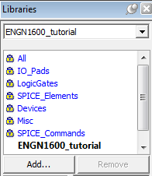

Building plans

Go to Cell > New View to open a layout cell ... You will see the following options:

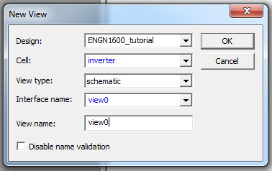

* Specify the name of the cell you want to build and then press OK. A fresh cell view is to open.
* NMOS, PMOS, Vdd, Gnd and In / Out ports are provided by a CMOS inverter. Click on the library software on the left hand side of the Libraries tab, the symbol artifacts will appear in the browser below. From of the chart consider the NMOS. Pick your computer and press Instance, or just drag - and - drop it to the display area. Make the same about symbols PMOS, Vdd, and Gnd. Before your drop the case, a window just like this one to the left can appear

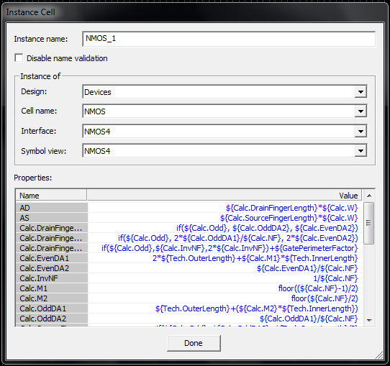

* A second window (like the one on the right) will appear on the right side of the device after instant period is lowered. We want to implement the property here, including the depth and diameter. And after putting the case, we often give it a mouse connection and modify its properties in the Navigator Properties on the right. Let's assume we set 50n and 150n for the length or width of NMOS devices, and 50n and 300n for the duration and breadth of PMOS devices, respectively.
* NOTE: the configuration must be modified from NMOS to NMOS VTG in order to run SPICE experiments for our libraries.

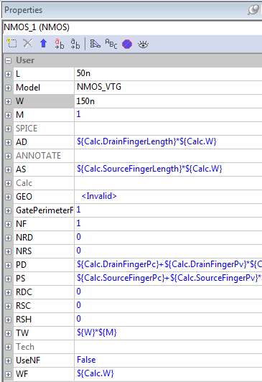

* You will need to switch the parts around to make the model appear the like you like it. If you press on a specific section of the layout, the THREE-BUTTON Cursor feature is displayed somewhere in the interface like this:



* ·Around this stage we need to switch to the graphical portion to pick some component of both an LEFT or RIGHT mouse trap and then use the MIDDLE capture to transfer. Instead, either press the portion, hold down the ALT key then push the component to the monitor somewhere. Using the View screen or the Scroll wheel cursor to zoom in or out or use the + symbol to zoom in and – sign to zoom out.
* Off possibility that we do have the basic components set up, the time has come to include I / O ports as well as wire the components together. Simply pick the knowledge port through yield ports on the diagram and assign the ports titles an extraordinary.

sedit5

* Then use the wiring tool to render correct terminal connections. When we press on the cable device, the wire begins with a SINGLE MOUSE CLICK. When you decide to stop cabling at a different spot, just give the DOUBLE CLICK.Your finished inverter diagram will look like that's at the input port and also at the output port.

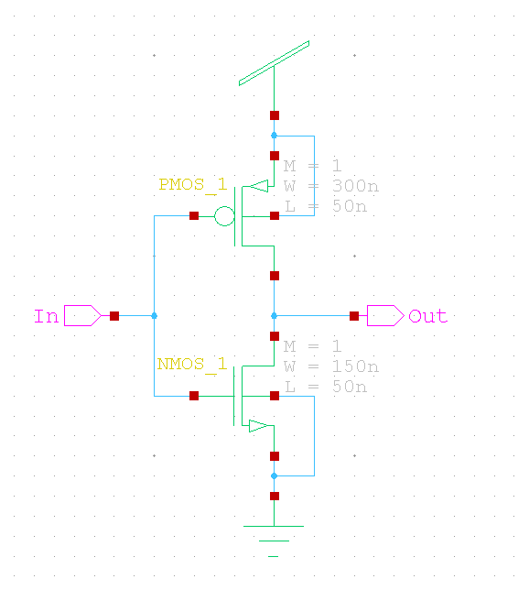

* That's how we created the links. Now we want to adjust the duration as well as the width of both the MOS transistors according to the specifications

**6.2.1 Symbol for inverter**

* The symbol is created as, first, build a View — construct a new cell with such an unique outlook of the symbol, or establish a new view of the current cell using Cell > Current View. Offer the title to the icon and choose the device to be connected to. Then use the ports w. Please ensure that perhaps the ports are given the same name as you are using in the Creating the symbol could be beneficial when you are doing hierarchical structure.

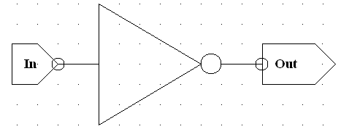

SPICE NETLIST WILL BE CREATED FROM THE SCHEMATIC

* Go to Import > Tab > Export Spice.
* Define the reference filename. Test Exclude.endin Options (could include the created SPICE file in many other SPICE files with the.end.)
* Export Tell.
* The SPICE file is stored in a schematic tab. The file includes details such as:
* MNMOS 1 Out NMOS VTG W=150n L=50n AS=135f PS=2.1u AD=135f PD=2.1u in GndGnd
* MPMOS 1 Out PMOS VTG W=300n L=50n AS=270f PS=2.4u AD=270f PD=2.4u in VddVddd
* As normal spice layout incomplete. It is only an enumeration of the right roof that is only created by us. To simulate the circuit, we can add several components, MOS by providing the stimuli feedback to the simulation.
* The summary material of the spice what we apply below.
* Simulate the Smrtspice circuit.
* when you've a spice ‘ portfolio by L-Edit / S-Edit, it's time to look at how to make the simulation finish.
* After conclusion of the simulation, save it and transfer the 45 nm model you are going to use with MOS prototypes to your tab. Using the provided password to open the folder once again.
* The SPICE Net database created by S-Edit includes the following details and is stored as an alternator.

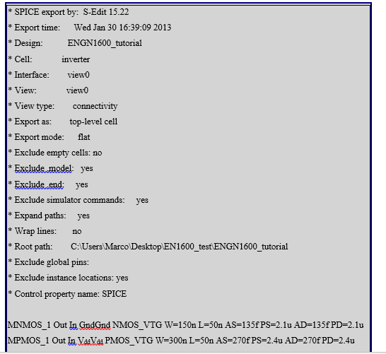

* This generated a SPICE file with a simple circuit body outline. Using the model library we can now include the portion listed, the power source, certain different simulation variables, the form of study and the stimulus input
* see spice sideboard. This file includes everything we want the alternator to research

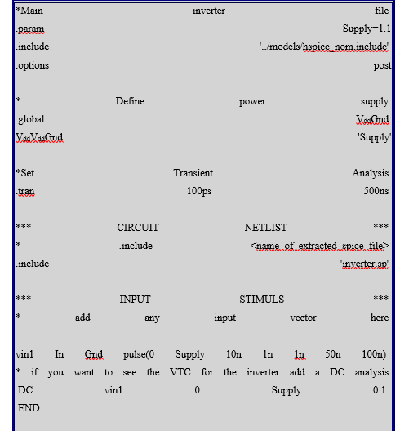

* When we switch from one style to another, the blue line would not be changed. The transient study requires adjusting. We want to adjust the date. due to setting the system enhancement for specific research. The invertsp can be displayed by the first red line, which will modify the spice-dependent file depending on the Tanner method. Thelabels were played from a third line. The green lines are used to write the dc analysis to build modify T voltage transfer functionality the green line demonstrates to use a DC examination to produce a VTC for the inverter. Send the Green line Statement if we don't run some DC research.
* And we're going to start with SPICE. On page 9 of this list a more comprehensive overview of a SPICE DECK is provided beginning.
* Recall the pattern index in a related database where the description is stored and repeat the spice deck.sp list in the design registry. This is important to include the different promoters into the declaration that might show all the directions.
* Using brilliant log, the complete spile will be made. The crafty filespice.
* Data documentation begin with the system of sourcing ... Drag the internet window deck Select the source capture, after the documents have been changed, save the folder by clicking the capture and supplying the appropriate data sources. SmartSpice must show paper inputs. There are no blunders you should not perceive.
* For inquiry tap on the analysis option and run alternate tan data box should pop up it should run it furthermore keep running through the using the simple route Ctrl-R.
* See the story info that looks like bwellneeds. Select the capture vectors. Various plots are available, and columns are seen themselves, so we move to another explanation. Tap the plot to tran1. To achieve the necessary yields and data sources go to more procedure. Bolding the lines at that point for demonstrated the great show up and knowing surely with the use of control key chosen by us.
* After the recreation has been done, reload it and reveal diverse Whether any modifications are made to the Spice input text after the recreational has been performed, then load this and run it again, we signify kinds of vectors that can be viewed as tran1, tran2, tran3, etc. Before clicking on the plot pick, make sure to deactivate your old plots, other informative old plots are popping up.
* Case: all the inputs and outputs for the reaction should be seen.
* wishing to mimic the two-entry switch, you must insure that the entrance fits in each of the four possible mixtures of knowledge (00, 01, 10 and 11). Suppose the two types of knowledge are called An, and B.
* 0 Supply 10n 1n 50n 100n AGndpulse vin1
* 0 Supply 10n 1n 100n 200n = vin2 B Gndpulse
* Because the two heartbeats will replicate each one of the four mixtures in one run.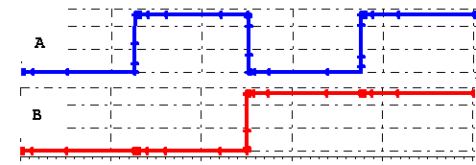

**6.2.2 How to add a little SPICE to design circuit**

* SILVACO's SmartSpice, the standard industry loop check system, will be used with this feature. This tutorial shows will give a basic thought on its most incredible method of composing flavor files starting without any external help and how to alter Tanner generated zest total records.
* · Before we continue, make sure your download the 45 nm Development Record (same hidden key) from here. Example of loop of a flavor plate.

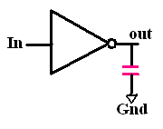

|  |
| --- |
| * Spice Net list of an Inverter  * This spice deck creates a simple inverter with an output load  * cap, runs a transient analysis and measures the propagation delay  ***********************************************************************  * Set supply and library  ***********************************************************************  .temp 27 * Set operating temp  .param Supply=1.1  .include '../models/hspice_nom.include' * the 45nm MOS model library  .options post * this will allow you to view the result  ***********************************************************************  * Define power supply  ***********************************************************************  .global VddGnd  VddVddGnd 'Supply'  ***********************************************************************  * Define Sub circuits  ***********************************************************************  .subcktinv In Out  M1 Out In GndGnd NMOS_VTG W=150n L=50n AS=135f PS=2.1u AD=135f PD=2.1u  M2 Out In VddVdd PMOS_VTG W=300n L=50n AS=270f PS=2.4u AD=270f PD=2.4u  .ends  ***********************************************************************  * Top level simulation net list  ***********************************************************************  x1 In Out inv  c1 Out Gnd 10f  ***********************************************************************  * Stimulus  ***********************************************************************  Vin In Gnd pulse(0 'Supply' 5n 100p 100p 25n 50n)  * Run a transient analysis  .tran .01ns 100ns  ***********************************************************************  * Measurements  ***********************************************************************  * measure delay of the inverter  .measure prop_delay  + TRIG v(In) VAL='Supply/2' RISE=1  + TARG v(Out) VAL='Supply/2' FALL=1  ***********************************************************************  * End of Deck  ***********************************************************************  .end |

Here are a few daily items you can notice in the zest deck above

• The deck's FIRST LINE is often interpreted as the 'Name.' Brisk comparison is support for every circuit to call complete.

• Every line beginning with a * is a Message and the system Seasoning would miss. Using # COM and # ENDCOM in SMARTSPICE on the unlikely chance you intend to use square remark.

• Eg.

#COM

this is a remark line1

this is a remark line2

#ENDCOM

• .temp explanation give the temperature in Celsius else it will defaults the room temperature.

• .the constants are incudes in the announcements which are composed in the programmeand know how "Supply" is utilized as a part of the above SPICE deck.

• .all articulation are incorporated into the announcement by the incorporate key ward. NMOS and PMOS display definitions for the 45nm strategy for the manufactures.

• Let's see the estimations of the "Vdd" and "Gnd" in circuits.

The items are clearly recreated by the media the grab duplicates any records found in the extension of the database. Anything I've looked at so far can be quickly recreated on every SPICE deck.temp has to be updated.

• This is a simple plan so in case we take the very complex overview, the subcircuit does not necessitate subcircuits. The real net rundown is planned by the basic concepts and the regular people is as subcircuitand mention input 1,2 and ends with post definition.

• Move to the relevant section. The key stage of the simulation system rundown.in that would help explain the relationships between fringe devices would be decided when such changes are finished. The release configuration of the considerable number of sequences is resisted after capacitances and transistors along with the greater part of the data and the input width of the duration and proportions is defined all over.

• The anther portion just clarifies the field of re-enactment used by data source patters. You'll just have the beat or the pwl (piecewise linear) for computerized reproductions. I prefer beat clarification over pwl. The reason for beat structure is:

Voltage node1 node2 Pulse (period start voltend voltinitial delayrise timepulse width)

And the reason for beat in the deck above:

Vin In Gndpulse (0 5n 100p 25n 50n "Supply")

Indicates heartbeat at hub In, starting ascending period is defined as time taken for the flag going 90% of its specific esteem and fall time would be the perfect chance for flag taking off 10% of its specific esteem.

• Up to now we've set up all the voltages and then the net breakdown of the equipment is just saying what kind of entertainment to use. Such only dc inquiry or transient test for the configuration of dc as seen below.start1 star2 ... as well as for the transient review.

• We will have a declaration at the finish. You can need to create certain calculations now and again, without going through a tedious procedure to extract those values from a story. Throughout the above example, the inverter provides the generation delay between the sources and yields of knowledge and the figure of the components that are voltage current power time here + picture indicates that not expansion but rather that as one line that is needed for certain lines, the zest of clarification is entered with regard to the previous lines. Likewise, for starters, this is how you can gage the inverter 's usual energy:

.The Natural Heat. For = 10n TO 50n

It shows the net rundown components again taking after the run section seamlessly at this stage. Want to enjoy next part.

We take this after the flavour 's circuit plan shows.

**Creating curve for pmos of v-I characteristics**

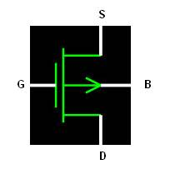

Copy the following SPICE deck to your folder. Make sure you have downloaded the [45nm](https://dropbox.brown.edu/download.php?hash=a135f64e)library file into the same folder.

|  |
| --- |
| *I-V curve PMOS  .param Supply=1.1  .include '../models/hspice_nom.include'  .options post  * Define power supply  .global VddGnd  VddVddGnd 'Supply'  *** CIRCUIT NETLIST ***  *** mpmos1 drain gate source bulk L= length W= width  M1 dsgsVddVdd PMOS_VTG W=500n L=160n  *** DEFINE VOLTAGE CONNECTIONS ***  **********************************  * you need to change some connections around for NMOS  * Voltage Name Node+ Node- Voltage Value  VdsVdd ds 'Supply'  VgsVddgs 'Supply'  ****************************************  *** INPUT STIMULS ***  *increase Vds from 0 to 1.1v with step of 0.01 increase Vgs from 0 to 1.1v with step of 0.2  .DC Vds 0 1.1 0.01 SWEEP vgs0 1.1 0.2  .END |

Open Smart Spice and load the spice deck. Run the spice deck.   
Plot i(Vdsvs.Vds)by clicking smartspice2and choosing i(Vds) from the list.

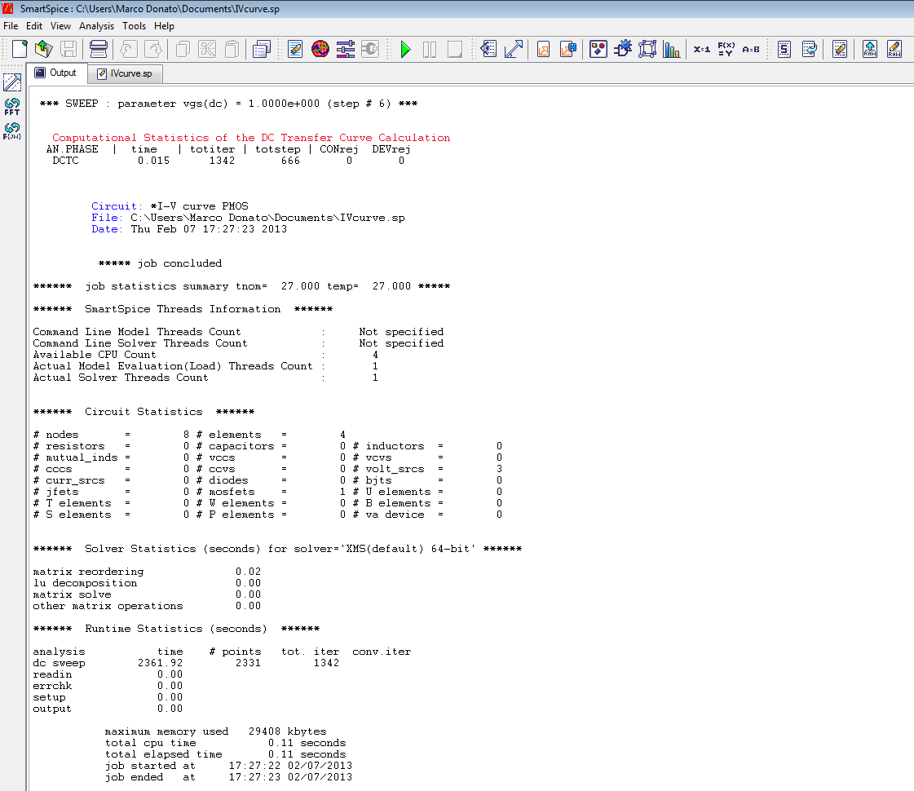

This will invoke SmartView and produce the following plot for the PMOS:

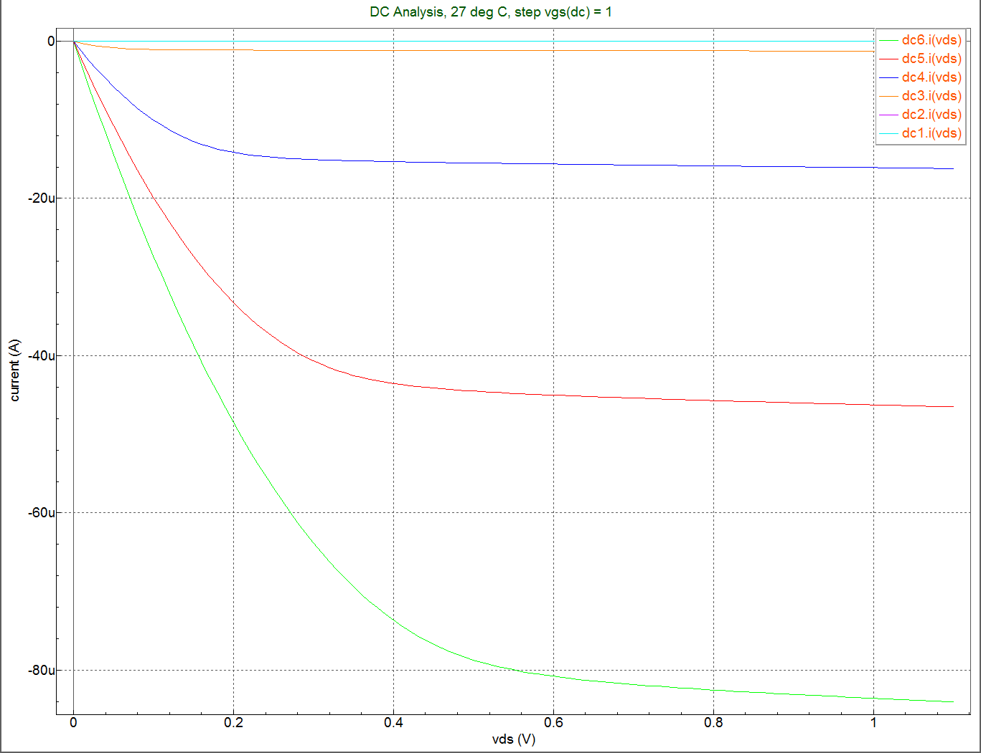

This should give you an idea of what to do for an NMOS.

**6.2.4 SmartSpice Plots**

After the complete analysis, click on smartspice2 from the toolbar to launch the vectors window.

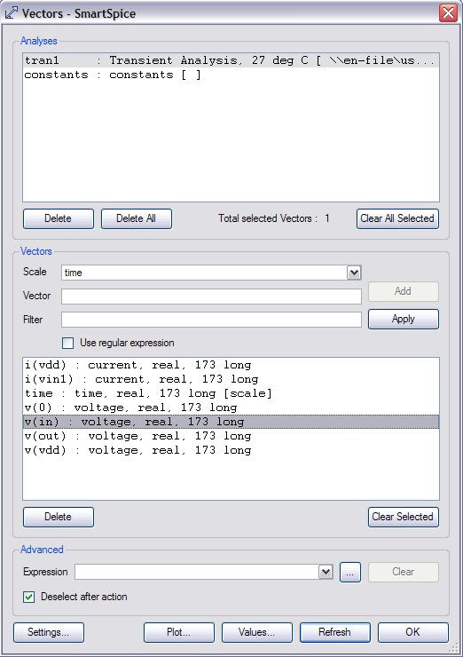

Tap on the voltage name that you need to print. Click Plot.

At the point when it's plotted in SmartView, tap on the left, which will begin another plot space.

In SmartSpice once more, tap on the second voltage name. Click Plot.

Rehash this procedure until we get the information and yield plotted

This will bring about every one of the sources of info and yield voltages on an indistinguishable plot from subplots.

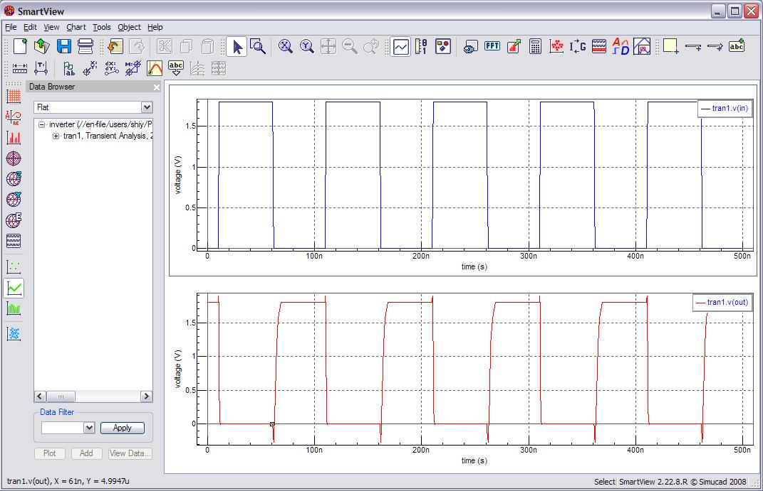

Easy for you to visualize and simulate.

If you have plotted two signals in one plot and want to split them up, right click on the plot and select Split All/Selected. Then it will show a stacked view.

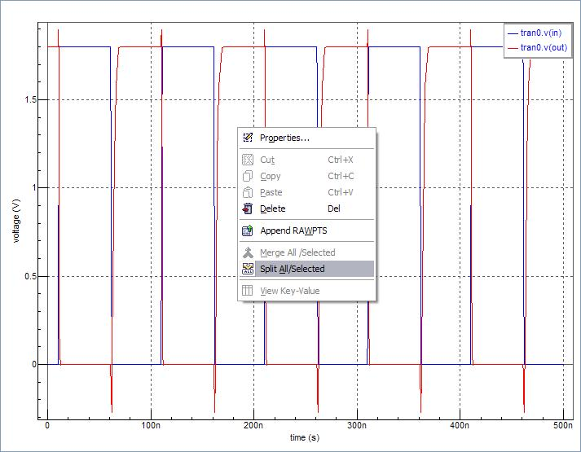

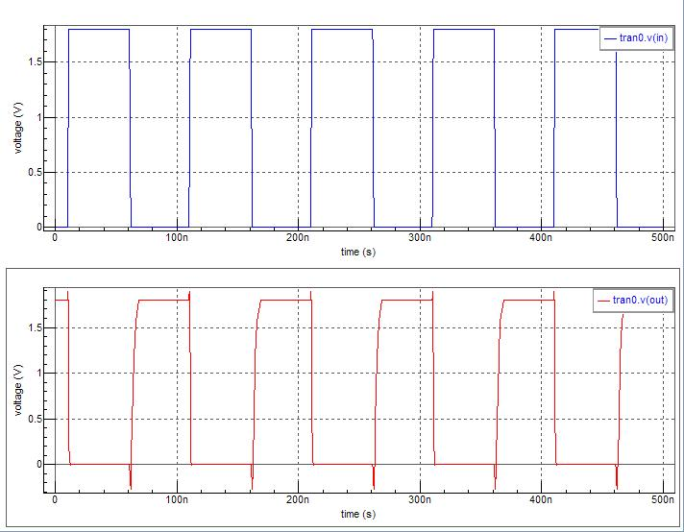

Because of default foundation will be dark. We can change this to a white foundation by going to Edit > Preferences > Colors and choosing a white foundation with dark tomahawks

CHAPTER 7

RESULTS

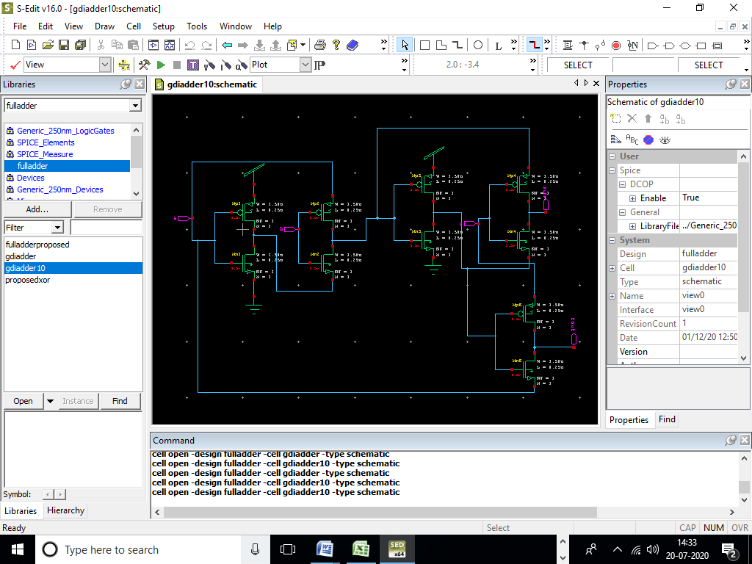

Fig 7.1 Circuit Diagram of Existing System

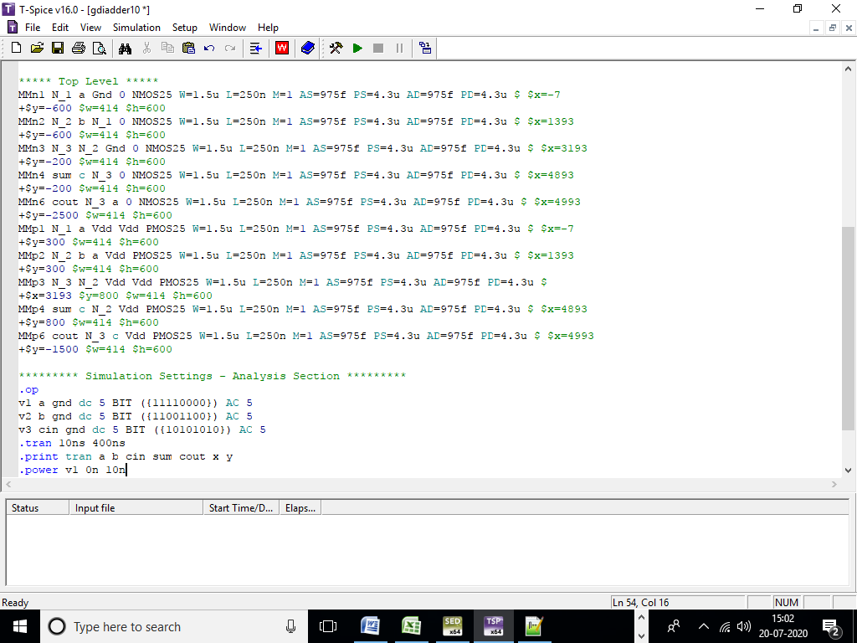

Fig 7.2 Spice code of existing System

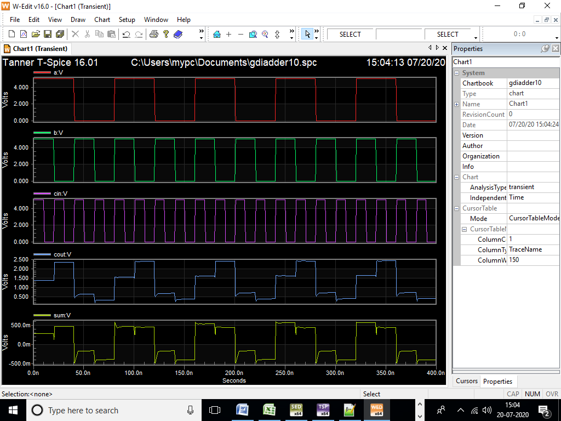

Fig 7.3 Simulation Result of existing System

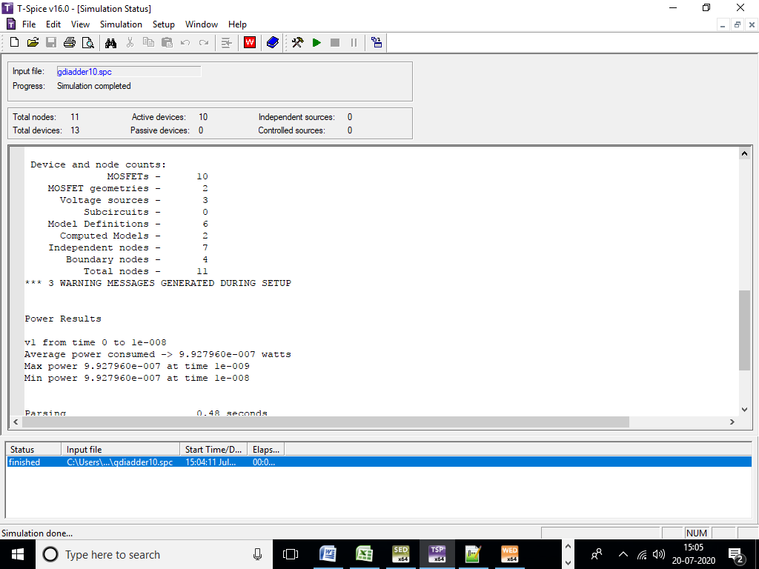

Fig 7.4 Area and power report of Existing System

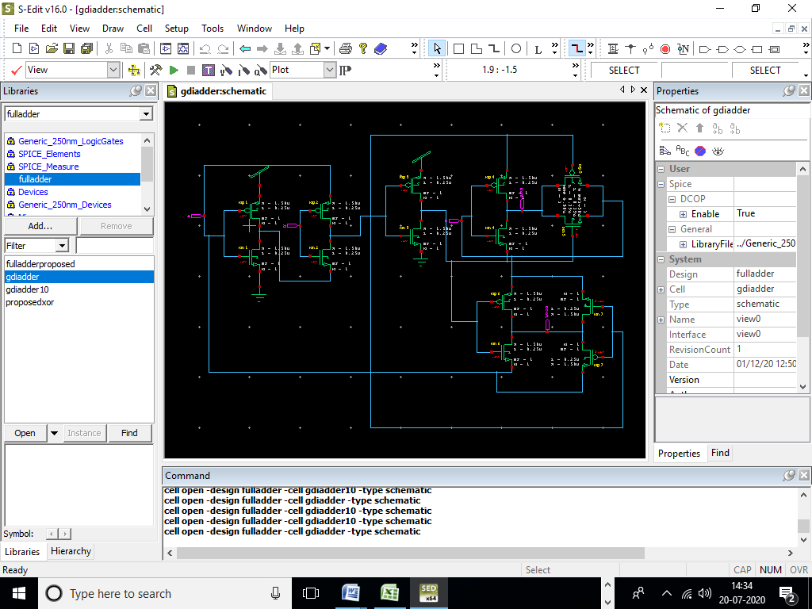

Fig 7.5 Circuit Diagram of proposed System

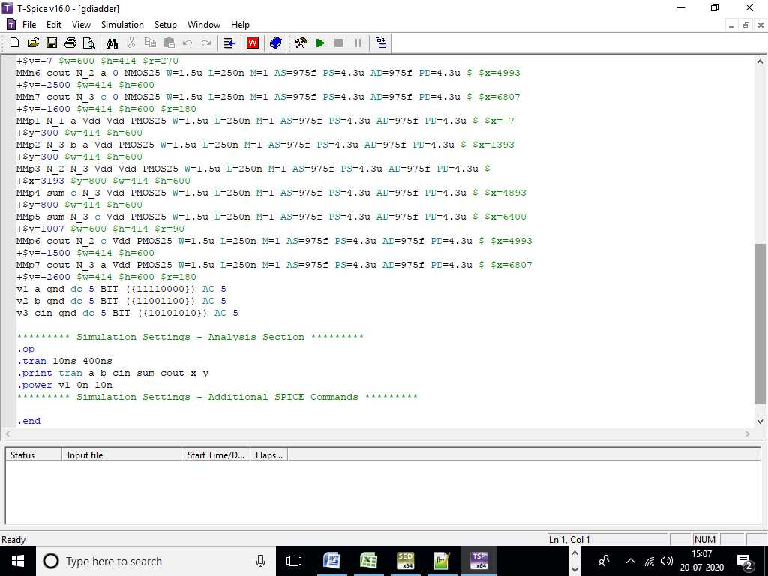

Fig 7.6 Spice code of Proposed System

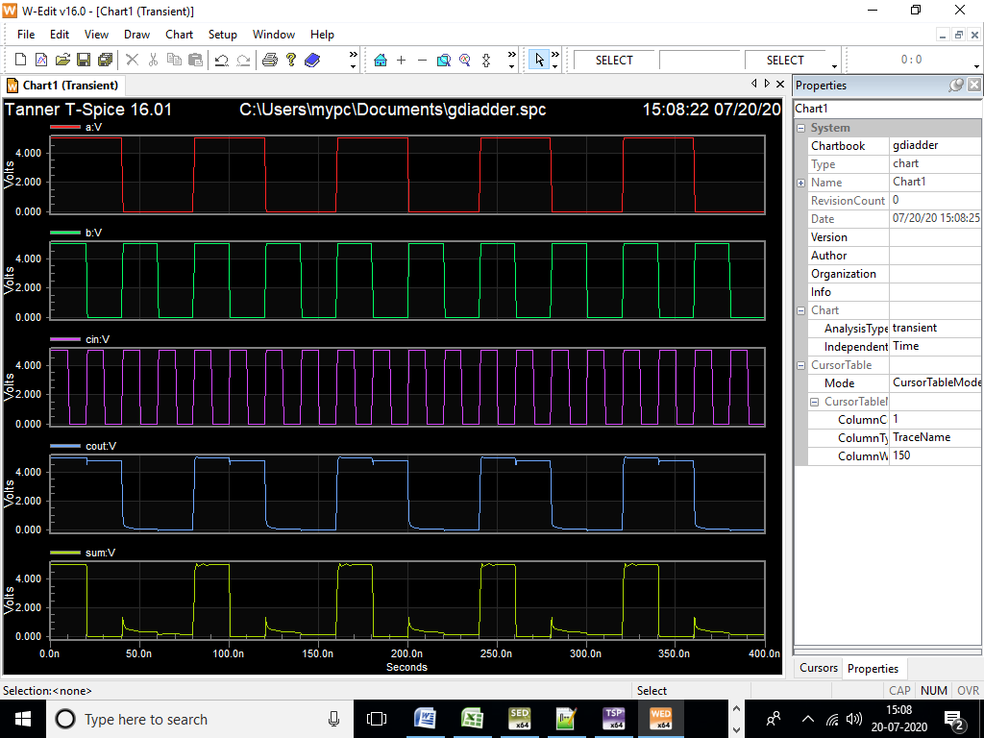

Fig 7.7 Simulation Result of Proposed System

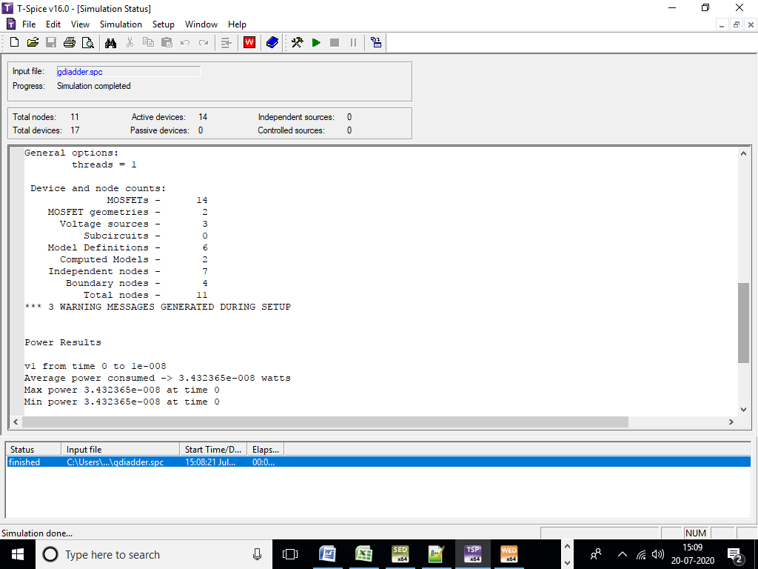

Fig 7.8 Area and Power Report of Proposed System]

Table 1 Compression Table

|  |  |  |  |
| --- | --- | --- | --- |
| S.no |  | Existing System | Proposed System |
| 1 | Area(Transistor) | 10 | 14 |
| 2 | power | 9.92*10-7 | 3.43*10-8 |

**CHAPTER 8**

**CONCLUSION**

The focus of this article was to use GDI technique to build a complete adder with high-speed output. From the data visualization table, it is evident that the process design system is the best in area, latency and energy dissipation among designs discussed. Because the tests have been collected as a consequence of modeling, the measurements are correct. This architecture would have an increased speed, and more of the platform's productivity relative to other traditional techniques. Additional changes to the system may be rendered by inserting another few transistors.

REFERENCES

[1] Tripti Sharma, K.G.Sharma and B.P.Singh,''High Performance Full Adder Cell: A Comparative Analysis'',2010 IEEE Students' Technology Symposium 3-4 April 2010,IIT Kharagpur, 2010.

[2] Rajkumar Sarma1 and Veerati Raju,'' Design and Performance Analysis of Hybrid Adders For High Speed Arithmetic Circuit'', International Journal of VLSI design & Communication Systems (VLSICS) Vol.3, No.3, June 2012.

[3] A. Morgenshtein, A. Fish, and I. Wagner, “Gate-diffusion input (GDI): a power-efficient method for digital combinatorial circuits,” IEEE Transactions on Very Large Scale Integration (VLSI) Systems IEEE Trans. VLSI Syst., vol. 10, no. 5, pp. 566–581, 2002.

[4] A. Morgenshtein, I. Shwartz, and A. Fish, “Gate Diffusion Input (GDI) logic in standard CMOS Nanoscale process,” 2010 IEEE 26th Convention of Electrical and Electronics Engineers in Israel, 2010.

[5] A. Morgenshtein, V. Yuzhaninov, A. Kovshilovsky, and A. Fish, "Fullswing gate diffusion input logic—Case-study of low-power CLA adder design," Integration, the VLSI Journal, vol. 47, no. 1, pp. 62–70, Jan. 2014.

[6] Korraravikumar, AL Reddy, M.Sadanandam, Santhoshkumar.A and M.Raju,'' Design of 2T XOR Gate Based Full Adder Using GDI Technique'', International Conference on Innovative Mechanisms for Industry Applications (ICIMIA 2017),2017.

[7] Jaume Segura, Charles F. Hawkins CMOS electronics: how it works, how it fails, Wiley-IEEE, 2004, page 132

[8] Clive Maxfield Bebop to the Boolean boogie: an unconventional guide to electronics Newnes, 2008, pp. 423-426

[9] Albert Raj/Latha VLSI Design PHI Learning Pvt. Ltd. pp. 150-153

[10] Yano, K, et al, "A 3.8 ns CMOS 16*16b multiplier using complementary pass transistor logic", IEEE J. Solid State Circuits, Vol 25, p388-395, April 1990

[11] Yingtao Jiang, Abdulkarim Al-Sheraidah, Yuke Wang, Edwin Sha, and Jin-Gyun Chung, “A Novel Multiplexer-Based Low-Power Full Adder” IEEE Transaction on circuits and systems-II: Express Brief, Vol. 51, No. 7,p-345, July- 2004

[12] Makoto Suzuki, et al, "A 1.5 ns 32 b CMOS ALU in double pass transistor logic", ISSCC Dig. Tech. Papers, pp 90-91, February 1993.

[13] N. Ohkubo, et al, "A 4.4 ns CMOS 54X54 b multiplier using pass transistor multiplexer", Proceedings of the IEEE 1994 Custom Integrated Circuit Conference, May 1-4 1994, p599-602, San Diego, California.

[14] Mohamed W. Allam, “New Methodologies for Low-Power High-Performance Digital VLSI Design”, PhD. Thesis, University of Waterloo, Ontario, Canada, 2000

[15] A.Bazzazi and B. Eskafi, "Design and Implementation of Full Adder Cell with the GDI Technique Based on 0.18μm CMOS Technology", International MultiConference of Engineers and Computer Scientists (IMES) Vol II, March 17 - 19, 2010, Hong Kong.